

OS: communicating between user and hardware

 **bootstrap program** is loaded at power-up or reboot

 Typically stored in ROM or EPROM, generally known as **firmware**

 Initializes all aspects of system

 Loads operating system kernel and starts execution





MODERN CoMPUTER WORKS



 Most systems use a single general-purpose processor

 Most systems have special-purpose processors as well

 **Multiprocessors** systems growing in use and importance

 Also known as **parallel systems**, **tightly-coupled systems**

 Advantages include:

**1. Increased throughput**

**2. Economy of scale**

**3. Increased reliability – graceful degradation** or **fault tolerance**

 Two types:

**1. Asymmetric Multiprocessing**

**2. Symmetric Multiprocessing**

Symmetric multiprocessing



**Process Management:**

 A process is a program in execution. It is a unit of work within the

system. Program is a ***passive entity***, process is an ***active entity***.

 Process needs resources to accomplish its task

 CPU, memory, I/O, files

 Initialization data

 Process termination requires reclaim of any reusable resources

 Single-threaded process has one **program counter** specifying

location of next instruction to execute

 Process executes instructions sequentially, one at a time, until completion

 Multi-threaded process has one program counter per thread

 Typically system has many processes, some user, some operating

system running concurrently on one or more CPUs

 Concurrency by multiplexing the CPUs among the processes / threads

The operating system is responsible for the following activities in connection with process management:

 Creating and deleting both user and system processes

 Suspending and resuming processes

 Providing mechanisms for process synchronization

 Providing mechanisms for process communication

 Providing mechanisms for deadlock handling

MEMORY MANAGEMENT

 All data in memory before and after processing

 All instructions in memory in order to execute

 Memory management determines what is in memory when

 Optimizing CPU utilization and computer response to users

 Memory management activities

 Keeping track of which parts of memory are currently being used

and by whom

 Deciding which processes (or parts thereof) and data to move into

and out of memory

 Allocating and deallocating memory space as needed

STORAGE MANAGEMENT

 OS provides uniform, logical view of information storage

 Abstracts physical properties to logical storage unit - **file**

 Each medium is controlled by device (i.e., disk drive, tape drive)

 Varying properties include access speed, capacity, datatransfer rate, access method (sequential or random)

 File-System management

 Files usually organized into directories

 Access control on most systems to determine who can access what

 OS activities include

 Creating and deleting files and directories

 Primitives to manipulate files and dirs

 Mapping files onto secondary storage

 Backup files onto stable (non-volatile) storage media

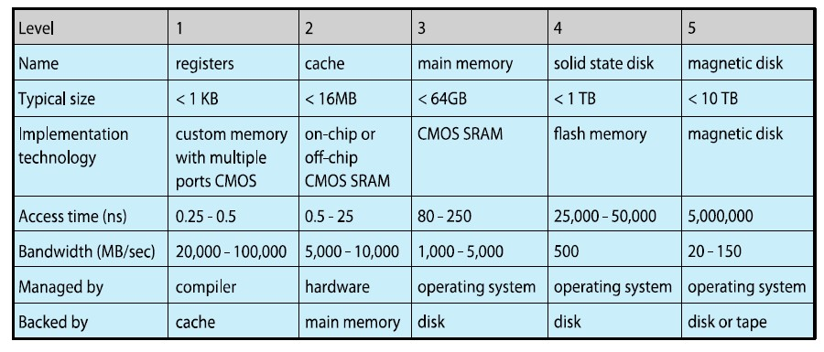

OPERATING SYSTEM SERVICES

 Operating systems provide an environment for execution of programs and services to programs and users

 One set of operating-system services provides functions that are helpful to the user:

 **User interface** - Almost all operating systems have a user interface (**UI**).

 Varies between **Command-Line (CLI)**, **Graphics User Interface (GUI)**, **Batch**

 **Program execution** - The system must be able to load a program into memory and to run that program, end execution, either normally or abnormally (indicating error)

 **I/O operations** - A running program may require I/O, which may involve a file or an I/O device

 **File-system manipulation** - The file system is of particular interest. Programs need to read and write files and directories, create and delete them, search them, list file Information, permission management.

 **Communications** – Processes may exchange information, on the same computer or between computers over a network

 Communications may be via shared memory or through message passing (packets moved by the OS)

 **Error detection** – OS needs to be constantly aware of possible errors

 May occur in the CPU and memory hardware, in I/O devices, in user program

 For each type of error, OS should take the appropriate action to ensure correct and consistent computing

 Debugging facilities can greatly enhance the user’s and programmer’s abilities to efficiently use the system

 Another set of OS functions exists for ensuring the efficient operation of the system itself via resource sharing

 **Resource allocation -** When multiple users or multiple jobs running concurrently, resources must be allocated to each of them

 Many types of resources - Some (such as CPU cycles, main memory, and file storage) may have special allocation code, others (such as I/O (devices) may have general request and release code

 **Accounting -** To keep track of which users use how much and what kinds of computer resources

 **Protection and security -** The owners of information stored in a multiuser or networked computer system may want to control use of that information, concurrent processes should not interfere with each other

 **Protection** involves ensuring that all access to system resources is controlled

 **Security** of the system from outsiders requires user authentication, extends to defending external I/O devices from invalid access attempts

 If a system is to be protected and secure, precautions must be instituted throughout it. A chain is only as strong as its weakest link

USER OPERATİNG SYSTEM INTERFACE-CLI

 CLI or **command interpreter** allows direct command entry

 Sometimes implemented in kernel, sometimes by systems program

 Sometimes multiple flavors implemented – **shells**

 Primarily fetches a command from user and executes it

– Sometimes commands built-in, sometimes just names of programs

» If the latter, adding new features doesn’t require shell modification

**System Calls**

 Programming interface to the services provided by the OS

 Typically written in a high-level language (C or C++)

 Mostly accessed by programs via a high-level **Application Program Interface (API)** rather than direct system call use

 Three most common APIs are Win32 API for Windows, POSIX API for POSIX-based systems (including virtually all versions of UNIX, Linux, and Mac OS X), and Java API for the Java virtual machine (JVM)

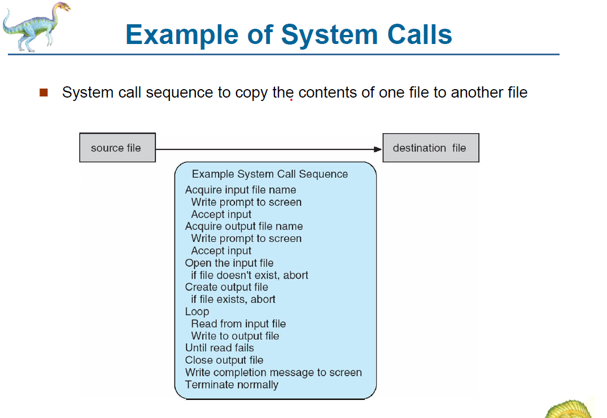

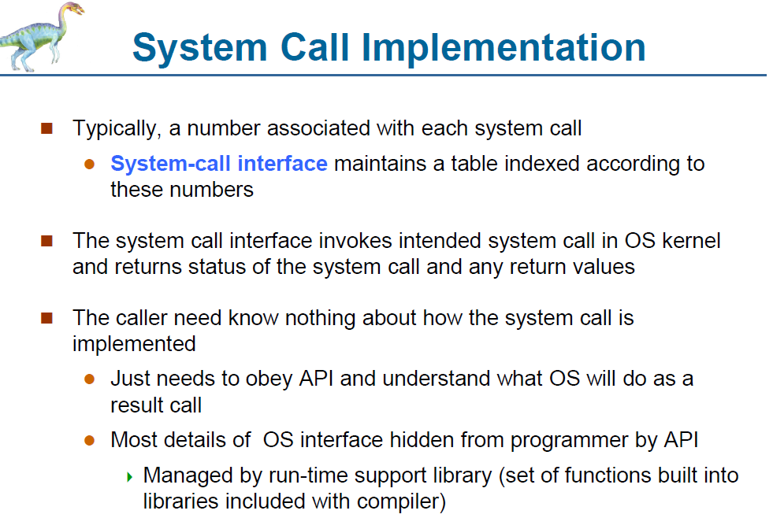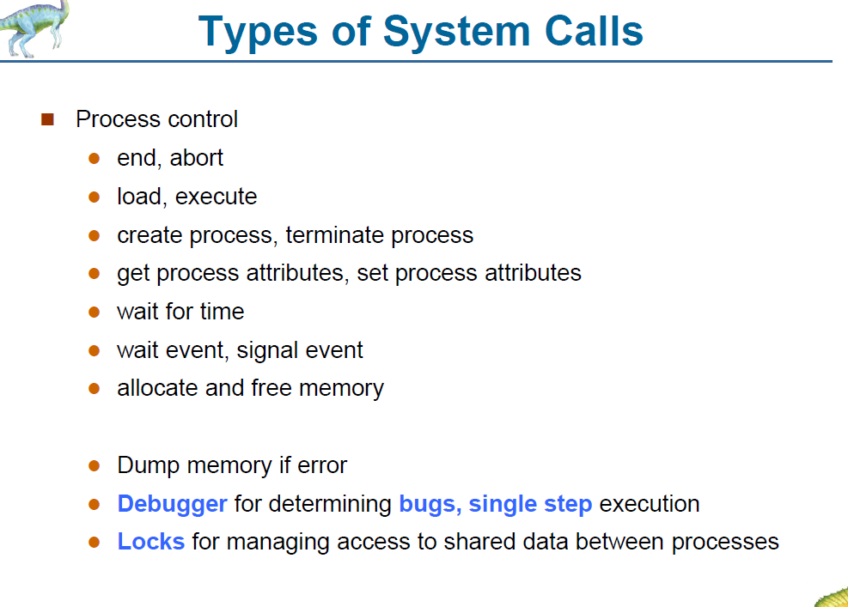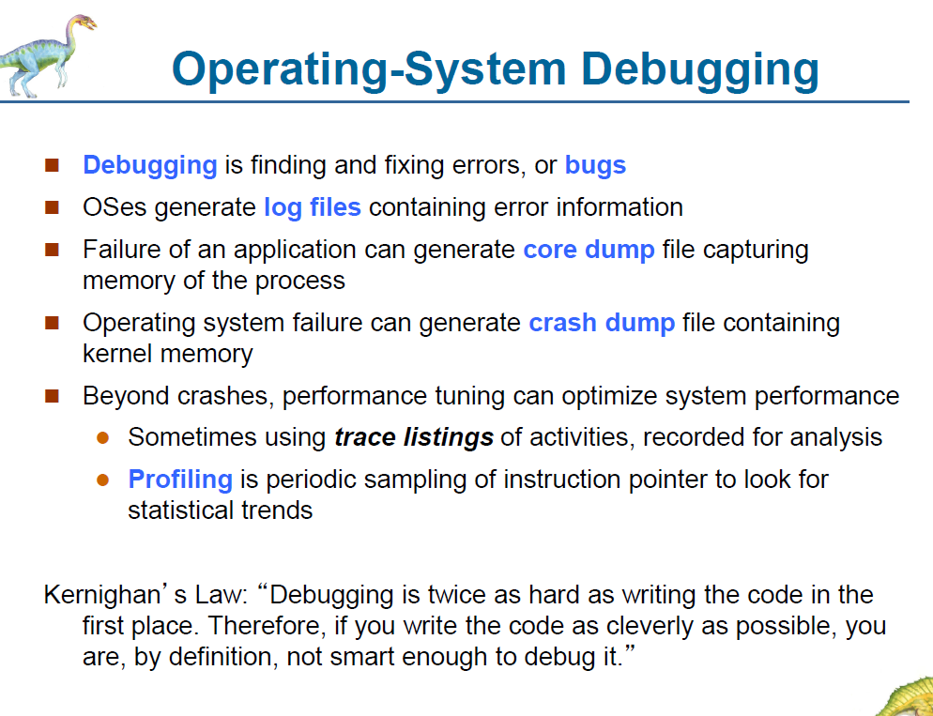

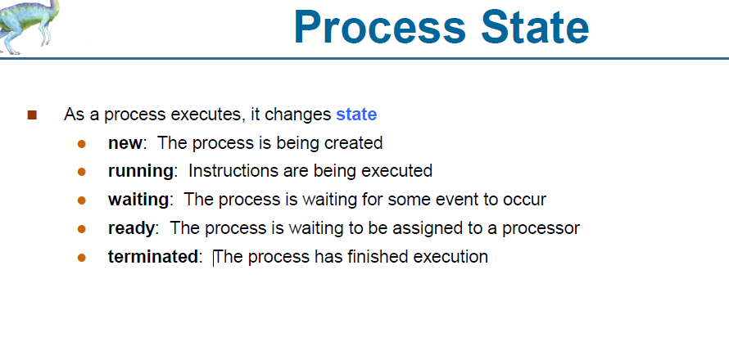

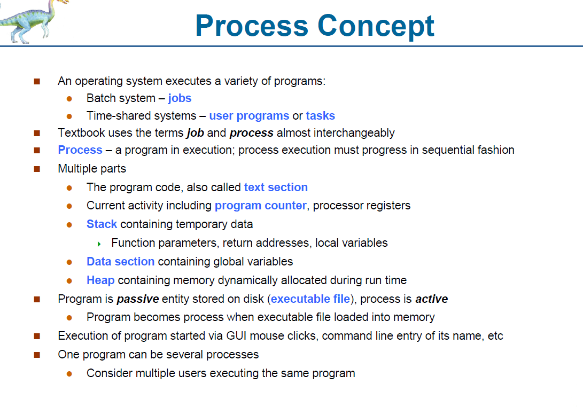

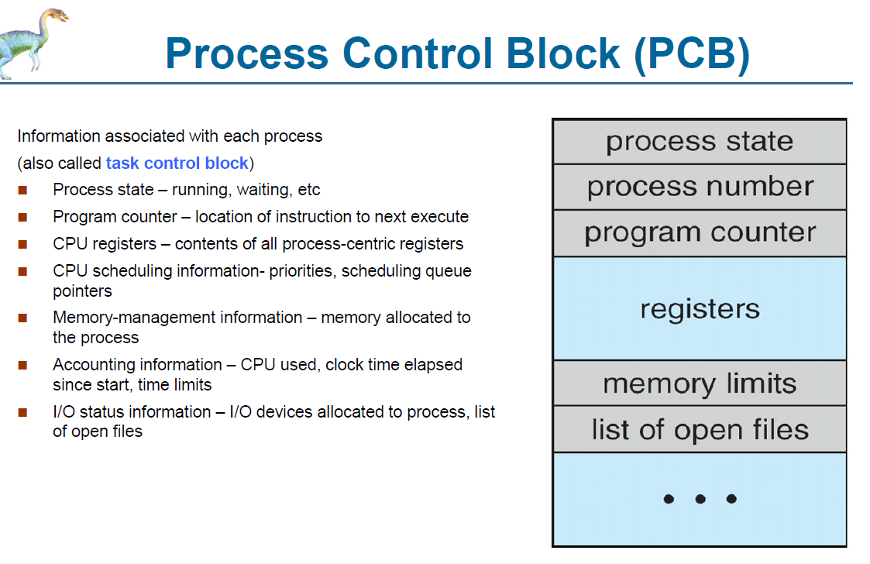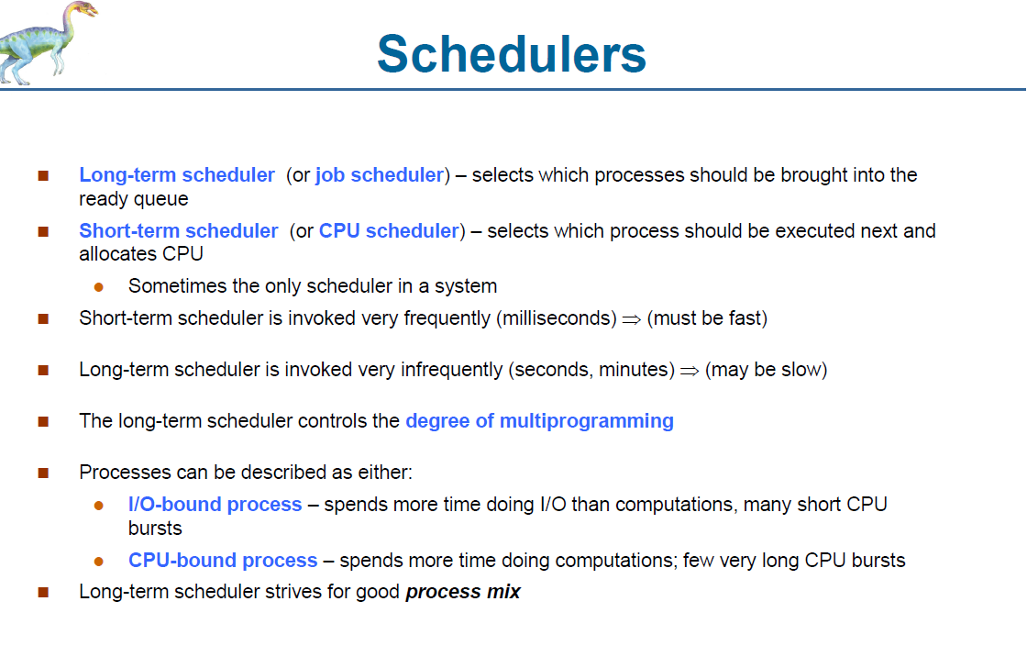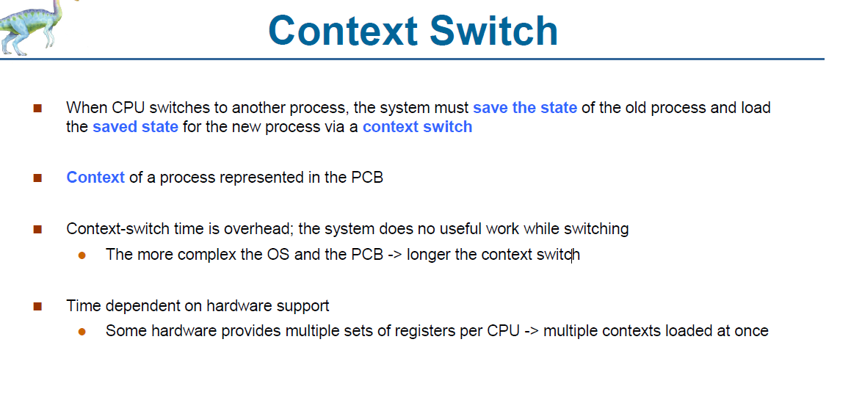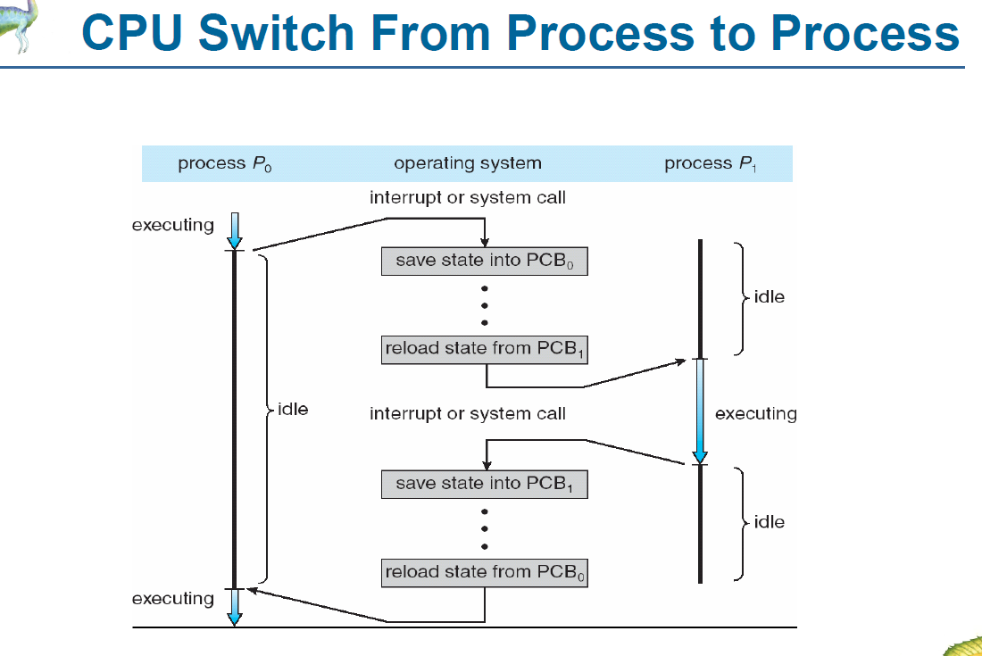

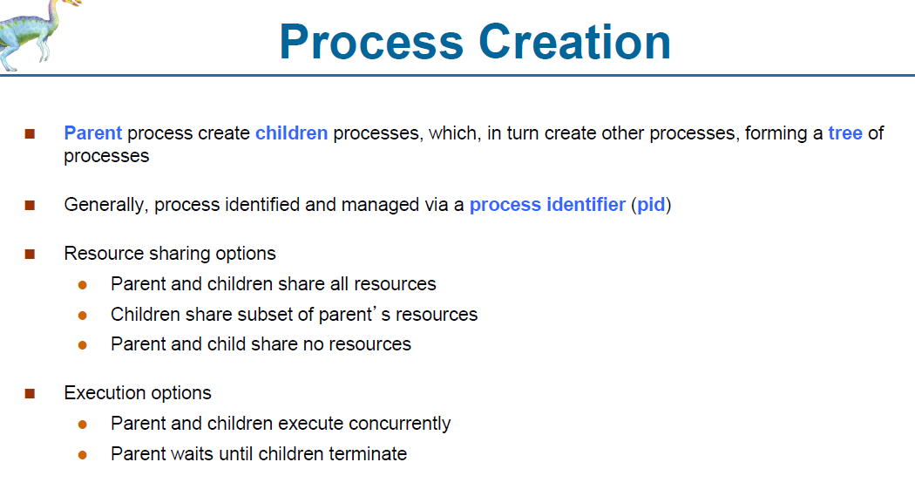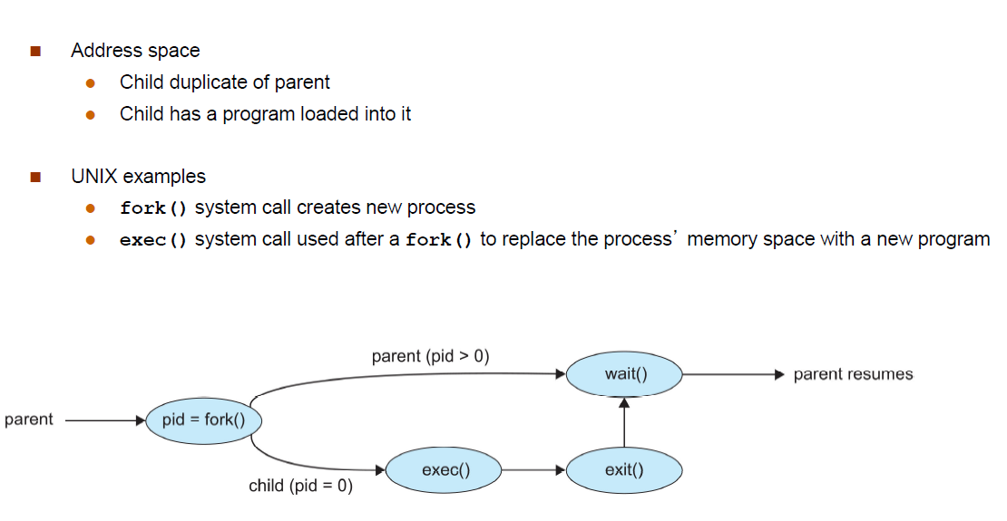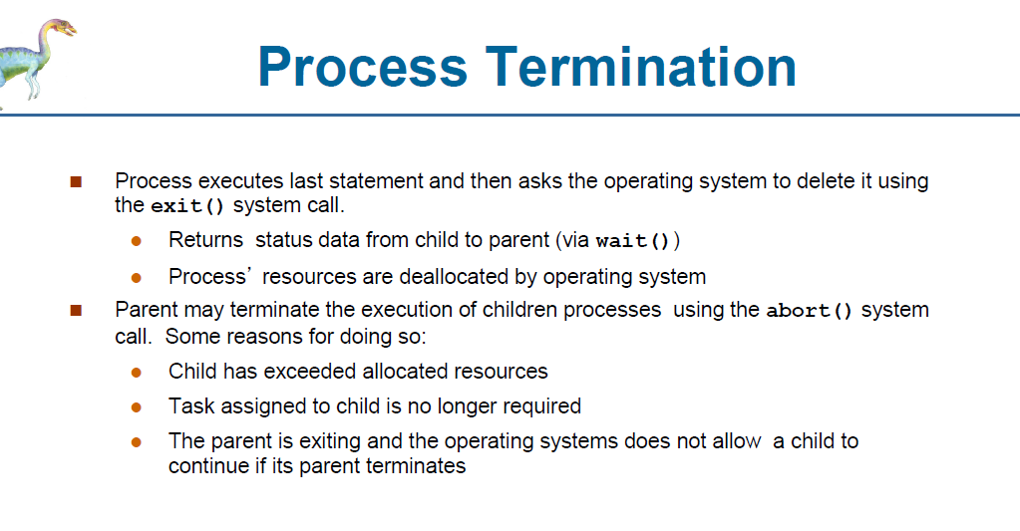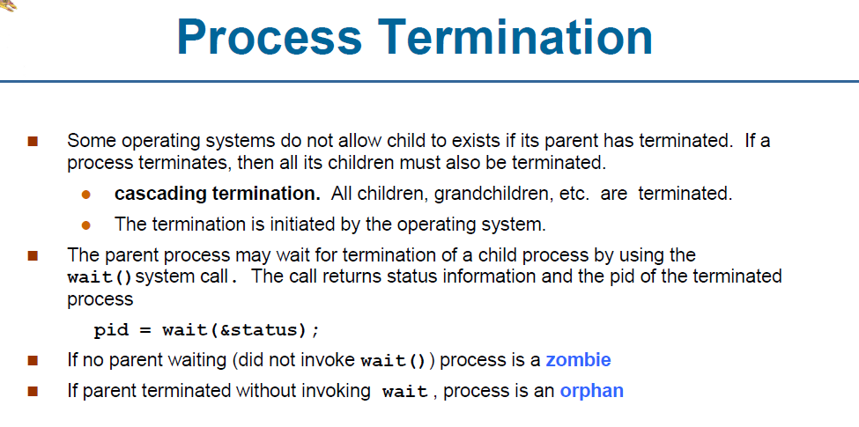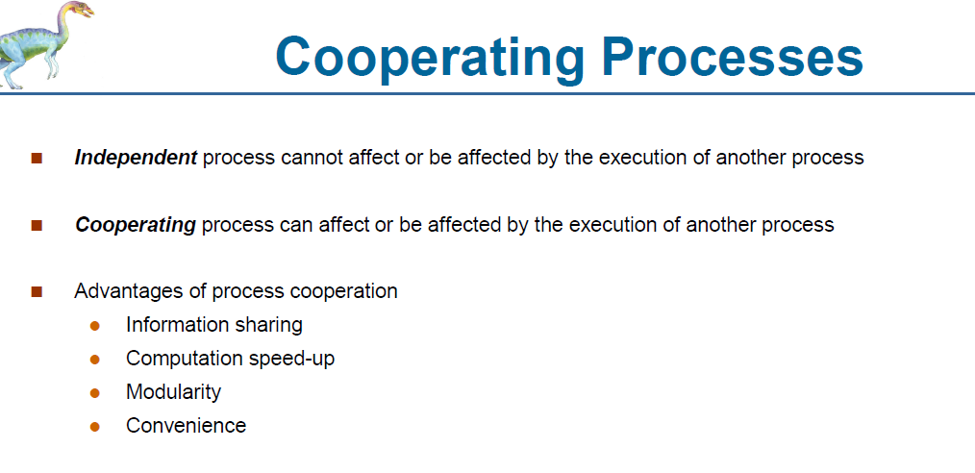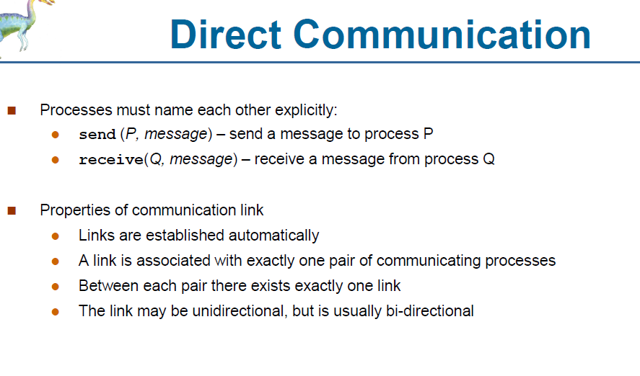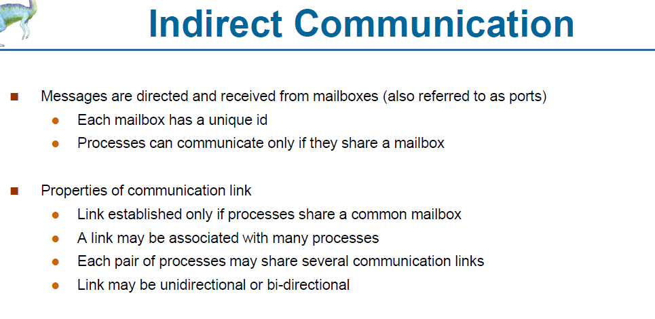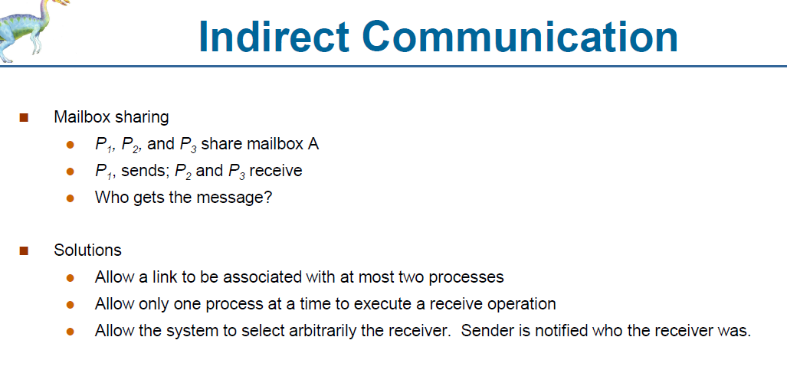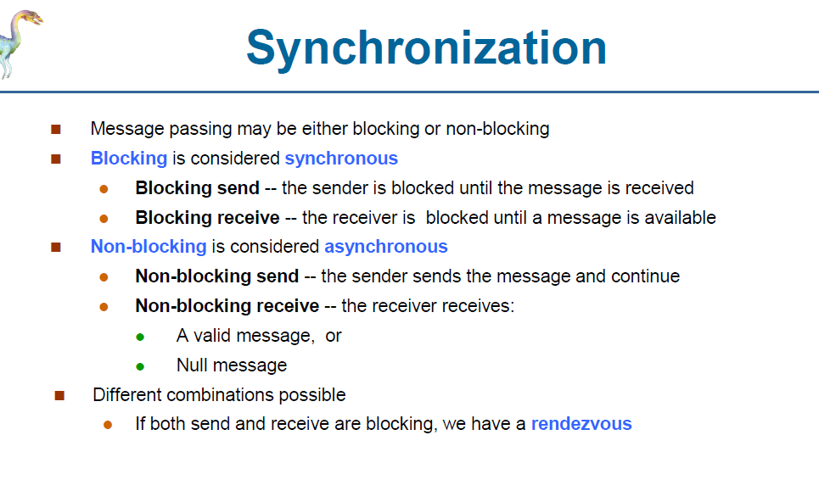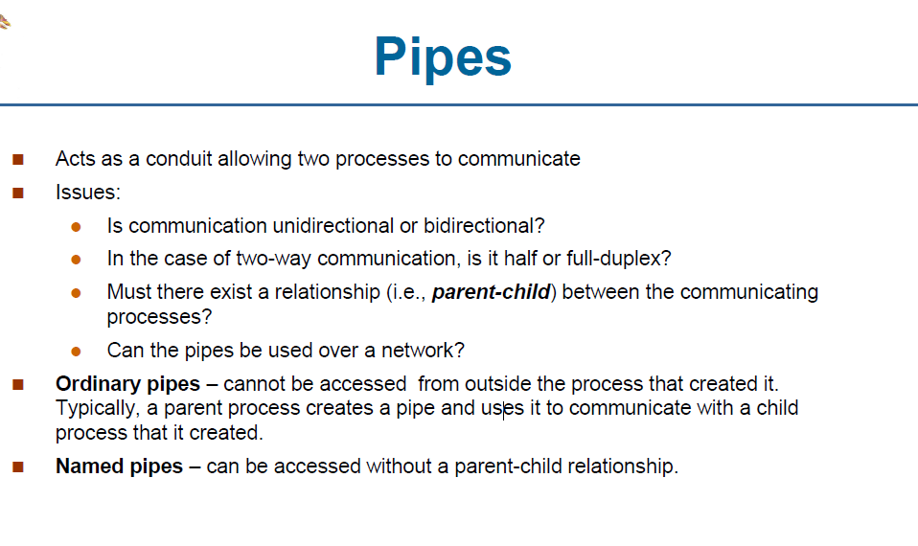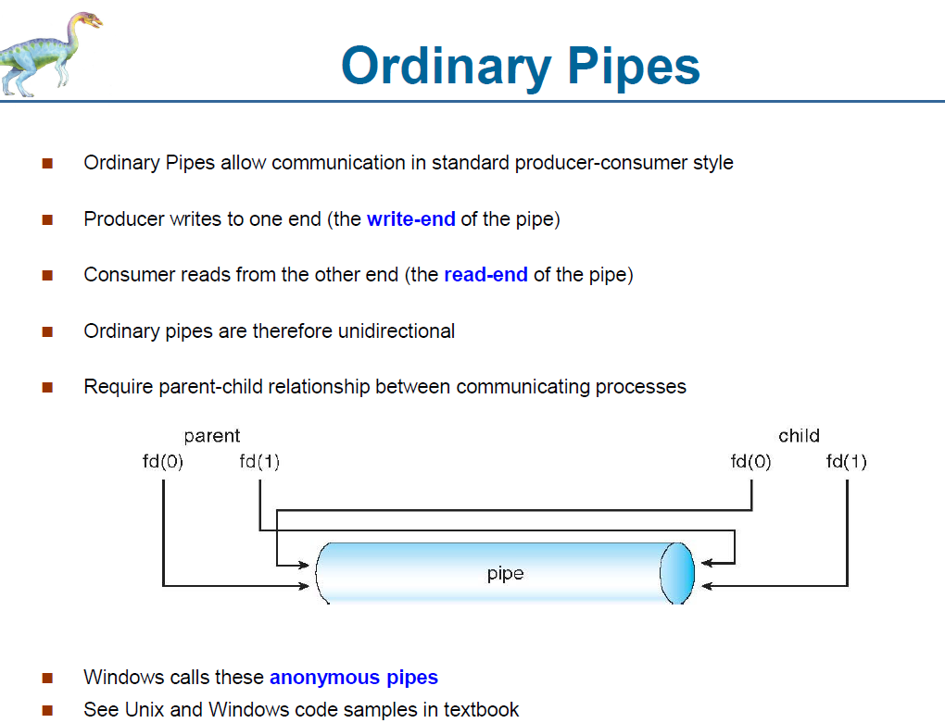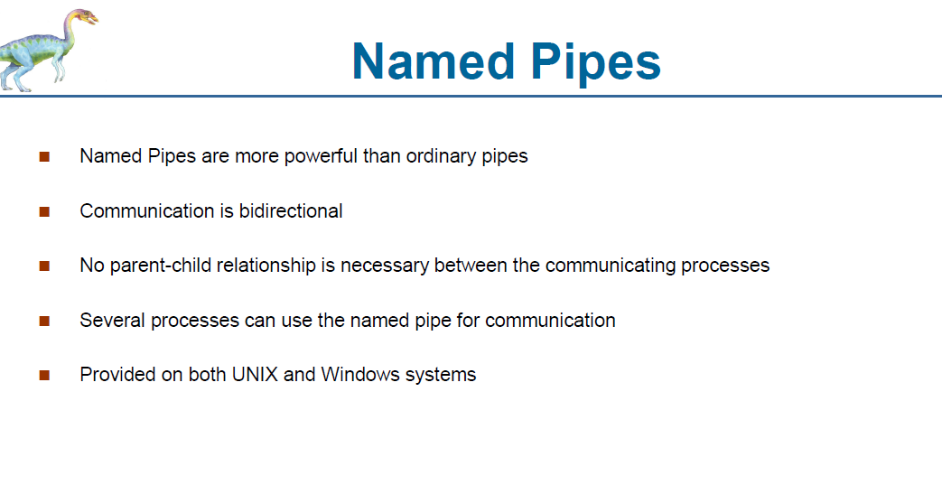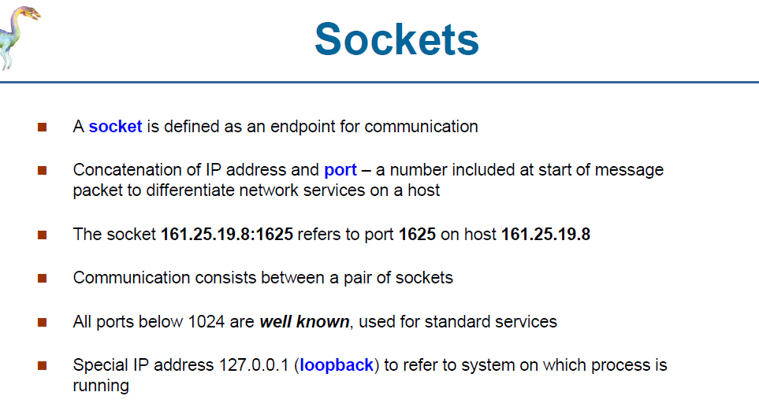

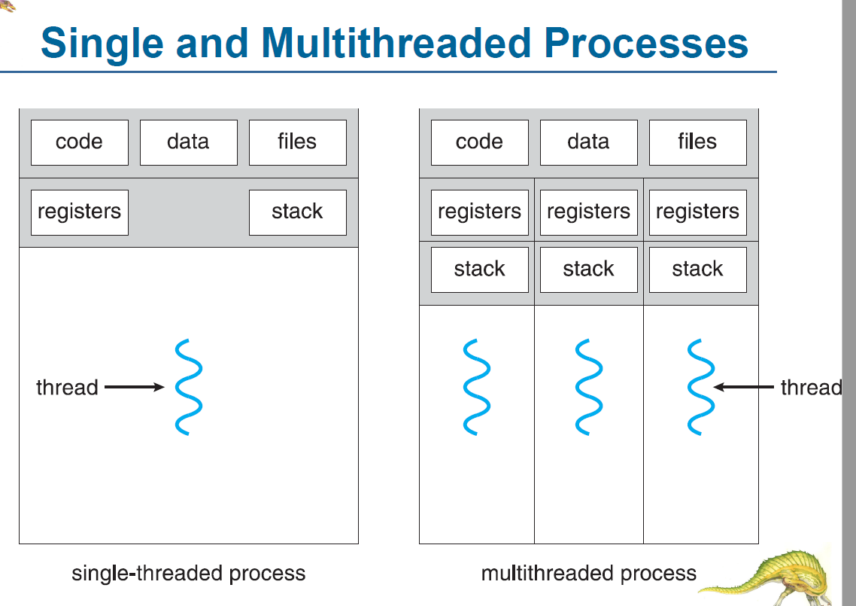

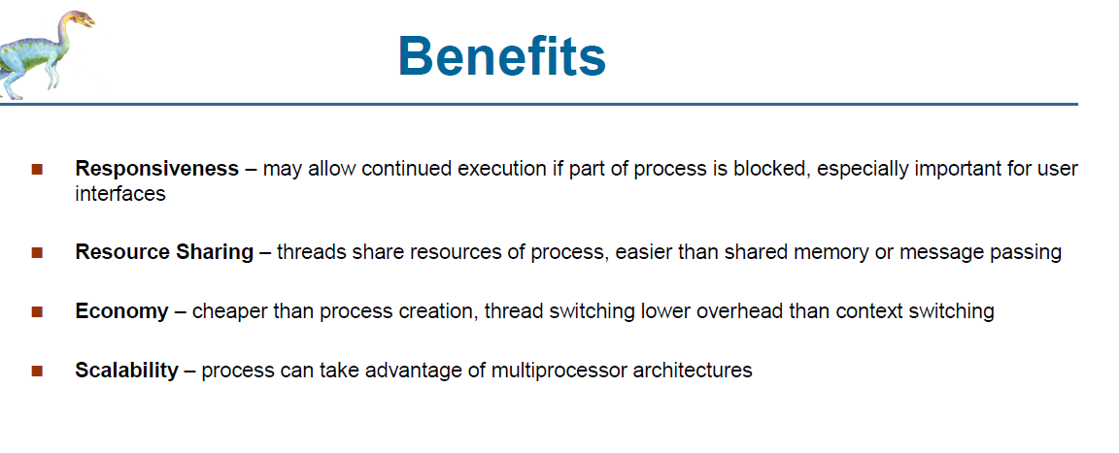

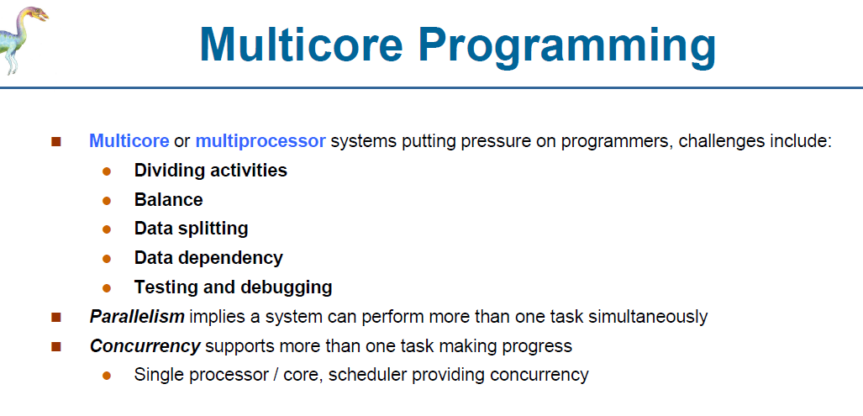

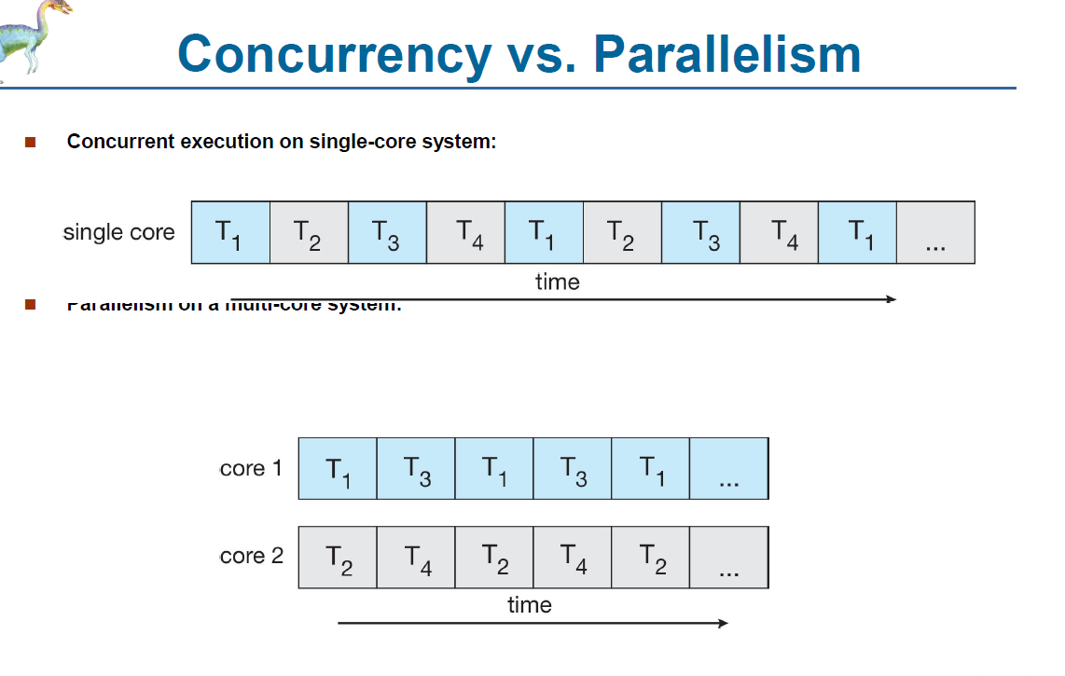

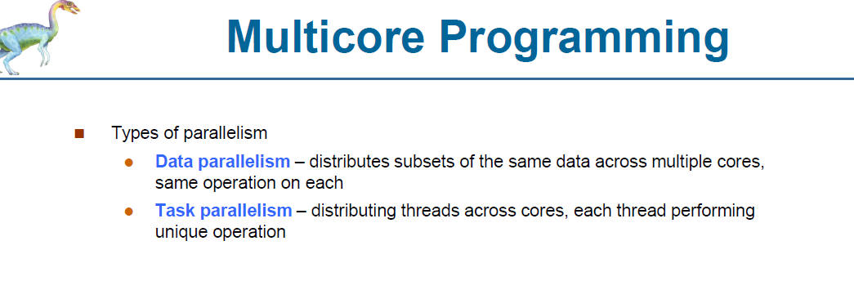

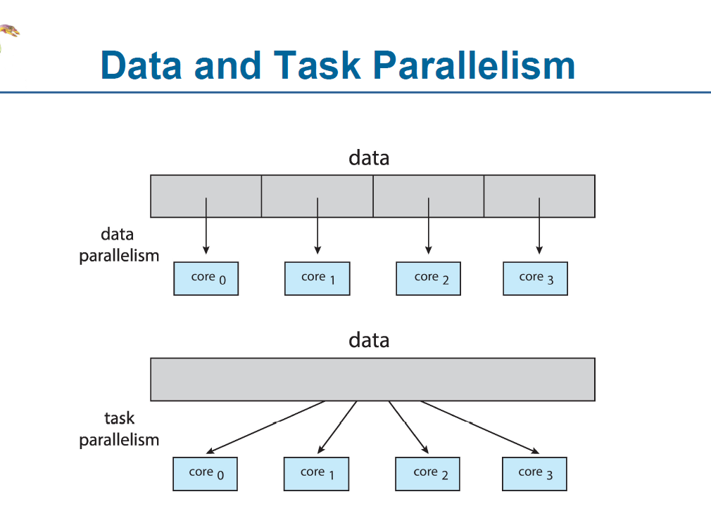

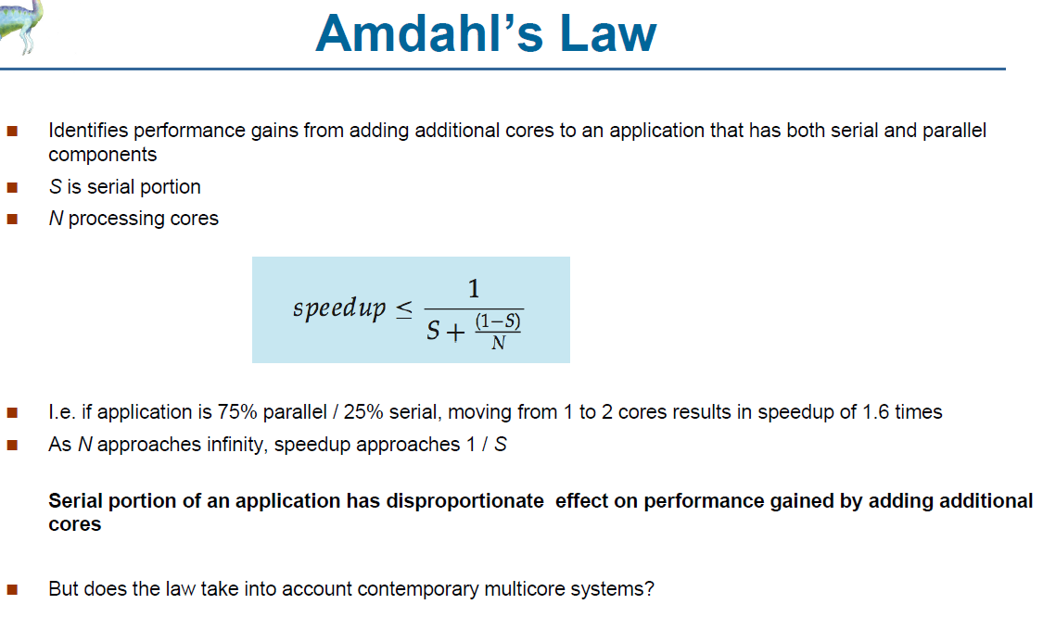

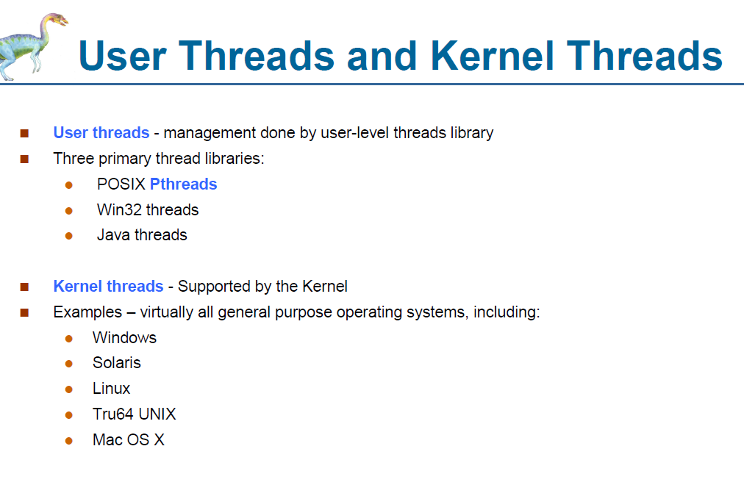

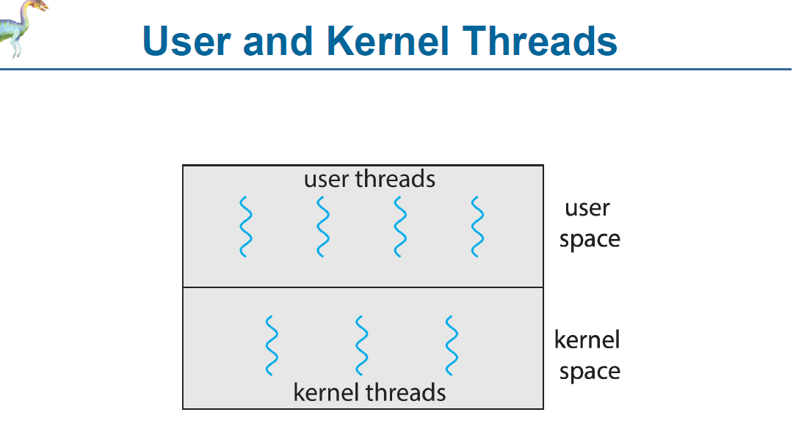

**Multithreading Models**

 Many-to-One

 One-to-One

 Many-to-Many

